Here is a summary of generating data points and re-run the analyses

1. Export xml file from Enterprise Architect.

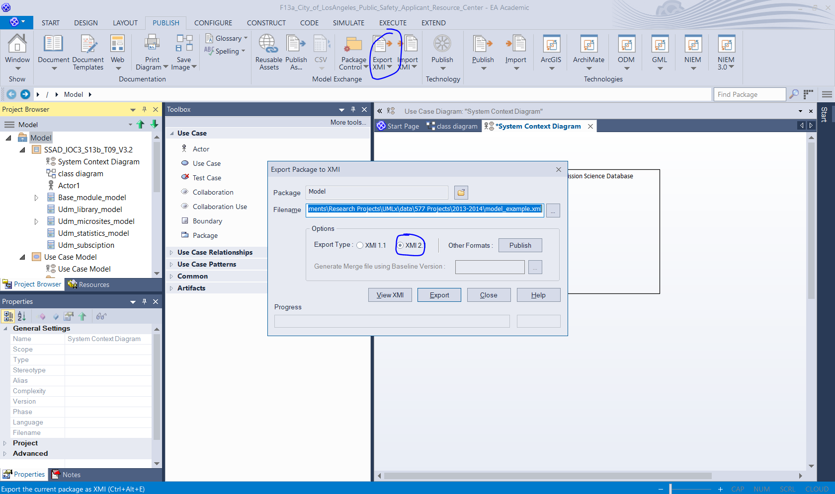

1. Rerun the analysis with the command:

node ./UMLxAnalyticToolKit.js "./data/577 Projects/2013-2014/model_example.xml" "./data/577 Projects/2013-2014/output" "project_file_name"

from the root of the project repository:

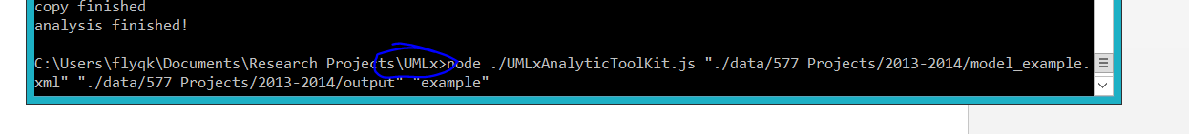

1. Find out the output data point and update the datasheet for statistical analysis.



Update the existing datasheet if the data point already exists, or add a new data point if it doesn’t.

